Employee Leave Management System
Problem Statement:
Develop a web application using Spring MVC with JdbcTemplate where employees can:
- Apply for leave
- View applied leave history
- Cancel their leave request
The admin can:
- View all leave requests
- Approve or reject leave applications

Architecture:
- Spring MVC – for the controller and web layer
- JdbcTemplate – for database interaction
- Model – simple POJOs for Employee and Leave
- MySQL – as the database
- JSP – as the view technology

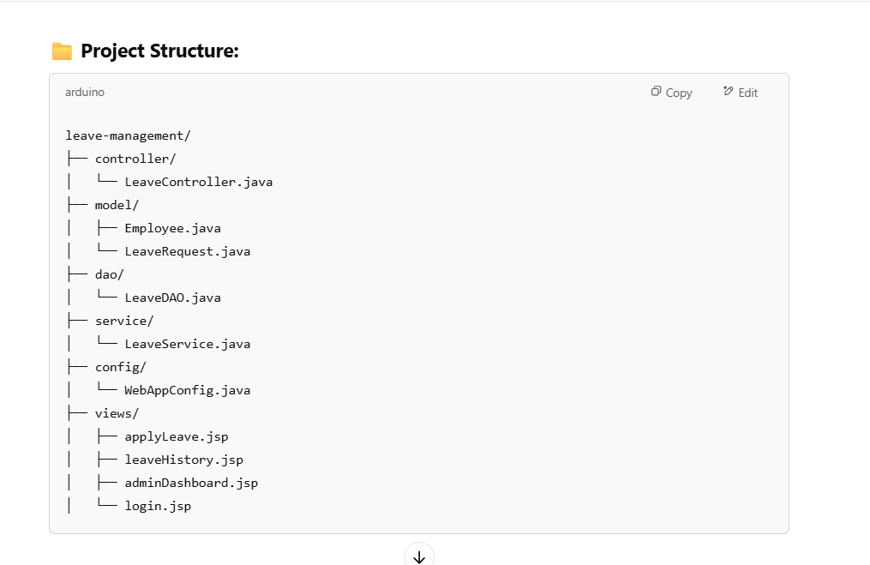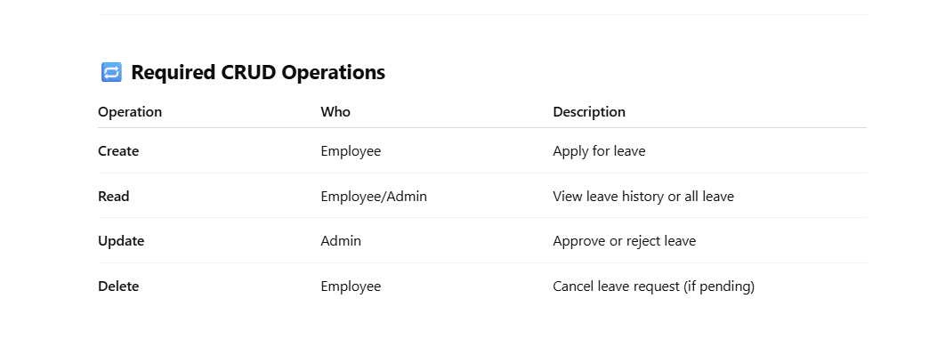

s

